**Steps to compute Doppler frequency at varying SV elevation for L1, L2, and L5 signals:**

Let *B* be the angle between the user and the Earth’s center, measured from the SV, *vs* be the GPS SV velocity, and *c* be the speed of light in m/s.

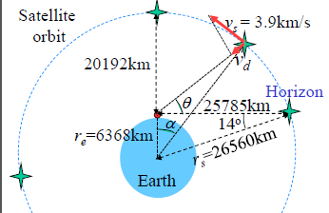Using the law of sines, we know that in general:

$$\frac{sin⁡(B)}{b}=\frac{sin⁡(C)}{c}$$

Therefore, we can solve for angle *B*:

$$B=sin\text{-1}\text{(b*}\frac{sin⁡(C)}{c})=sin\text{-1}\text{(}r_{e}\text{*}\frac{sin⁡(θ+90°)}{r_{s}})$$

*B* is used to compute angle *a* and subsequently, *vd*:

From there, Doppler frequencies can be calculated for each GPS signal:

$$f_{d}^{L1}=f_{L1}*\frac{v_{d}}{c}$$ $$f_{d}^{L2}=f_{L2}*\frac{v_{d}}{c}$$ $$f_{d}^{L5}=f_{L5}*\frac{v_{d}}{c}$$